[Butternut Squash and Black Bean Enchiladas](http://www.skinnytaste.com/2013/11/butternut-squash-and-black-bean.html)

[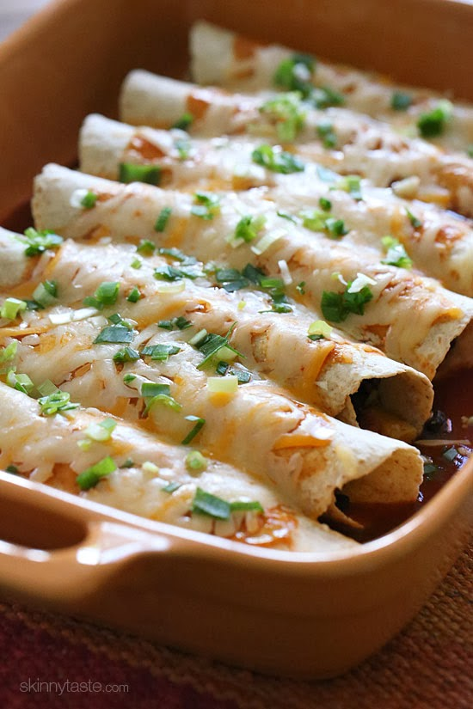](http://3.bp.blogspot.com/-cHq9YWz3YkU/Unek7hbIHeI/AAAAAAAAMmo/--xuzunUnR0/s1600/butternut-squash-and-black-bean-enchiladas.jpg)

[](http://pinterest.com/pin/create/button/?url=http://www.skinnytaste.com/2013/11/butternut-squash-and-black-bean.html&media=http://3.bp.blogspot.com/-cHq9YWz3YkU/Unek7hbIHeI/AAAAAAAAMmo/--xuzunUnR0/s1600/butternut-squash-and-black-bean-enchiladas.jpg&description=Butternut%20Squash%20and%20Black%20Bean%20Enchiladas)

Butternut squash, black beans, tomatoes, cilantro and spices are simmered in a skillet with green chilies and jalapeno, then wrapped in tortillas and baked in the oven with enchilada sauce and cheese – these vegetarian enchiladas are delicious and perfect for meatless Mondays, or any day of the week!

[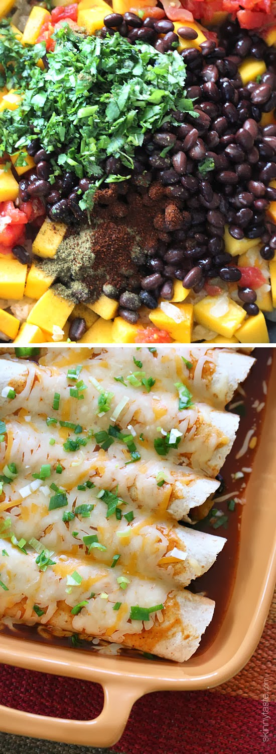](http://4.bp.blogspot.com/-h5L1o68RGvg/Unek7ln_wII/AAAAAAAAMms/We0aS9b8qEg/s1600/black-bean-butternut-squash-enchiladas.jpg)

Yup, I'm pretty enchilada obsessed and this meatless version did not dissappoint. Because of my love affair with enchiladas, I always make my own enchilada sauce and keep it frozen; you can use the recipe from my [skinny chicken enchiladas](http://www.skinnytaste.com/2010/02/chicken-enchiladas.html) but if you're pressed for time store bought enchilada sauce would be fine. Canned beans are inexpensive so this is a great meal if you're on a budget. I served this with [fiesta lime rice](http://www.skinnytaste.com/2011/04/fiesta-lime-rice.html), but you can also have this with [cilantro lime cauliflower "rice"](http://www.skinnytaste.com/2013/10/cilantro-lime-cauliflower-rice.html) to keep the carbs low.  
  
Butternut squash has so many health benefits; it's low in fat, loaded with fiber, rich in antioxidants, vitamin C and beta-carotene, just to name a few. Combine that with black beans which are super high in fiber and protein and you have one healthy dish which is not only satisfying, it tastes great too. Enjoy!  
  
  
**Butternut Squash and Black Bean Enchiladas**  
*Skinnytaste.com*  
Servings: 8 • Size: 1 enchilada • Old Points: 4 pts • Points+: 5 pts  
Calories: 185 • Fat: 6 g • Protein: 13 g • Carb: 29 g • Fiber: 13 g • Sugar: 2 g   
Sodium: 864 mg • Cholesterol: 7.5 mg  
  
Ingredients:

* 1 cup red enchilada sauce ([homemade](http://www.skinnytaste.com/2010/02/chicken-enchiladas.html) or canned)
* 1 tsp olive oil
* 2 1/2 cups peeled butternut squash, cut 1/2-inch-dice
* salt and pepper, to taste
* 1 small onion, diced
* 3 cloves garlic, minced
* 1 jalapeno, seeded and diced
* 10 oz can Rotel tomatoes with green chilies
* 1 1/2 cups reduced sodium canned black beans, rinsed and drained
* 1/4 cup cilantro
* 1 tsp cumin
* 1/2 tsp chili powder
* 1/4 cup water
* 8 medium low-carb whole wheat flour tortillas (I used La Tortilla Factory)
* 1 cup reduced-fat shredded Mexican cheese
* 2 tbsp chopped scallions, for garnish
* reduced-fat sour cream, for serving (optional)

Directions:  
    
Preheat the oven to 400°F. Place 1/4 cup enchilada sauce on the bottom of a large baking dish.  
  
Heat olive oil over medium-high heat in large skillet. Add onions, garlic, and jalapeno and cook 2-3 minutes until onions become translucent and garlic is fragrant. Add cubed butternut, Rotel tomatoes, black beans, water,  cilantro, cumin and chili powder and season with salt and pepper to taste. Cover and cook over medium-low heat, stirring occasionally, until the squash is tender, about 30 to 35 minutes.

[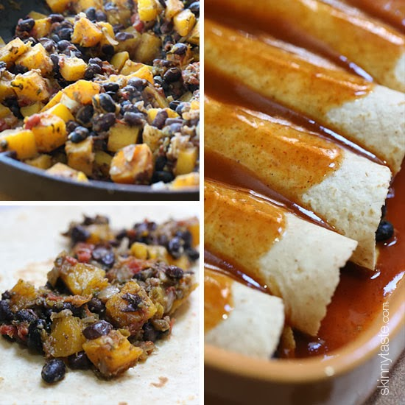](http://3.bp.blogspot.com/-foBqshUKrIQ/Unek8XxNFuI/AAAAAAAAMm0/Wj5ZzdmFmQ0/s1600/vegetarian-butternut-squash-and-black-bean-enchilada-recipe.jpg)

Place about a generous 1/3 cup filling in the center of each tortilla and roll, place on the baking dish seam side down. Repeat with the remaining filling. Top with remaining enchilada sauce and cheese and bake, covered with foil until hot and the cheese is melted, about 10 minutes. Top with scallions and eat with sour cream if desired.